LAB-9
MAP SIDE AND REDUCE SIDE JOIN

PRIYANSHU SHARMA
15BCE1282

CODE

- Create the employee details(eid,ename,designation) file and the department details(eid,department) file in HDFS. Let the department details can be stored using disttributed cache. Write the employee id, name, designation and department in the HDFS. Use map side join.

CODE

import java.io.BufferedReader;

import java.io.FileReader;

import java.io.IOException;

import java.util.*;

import org.apache.hadoop.filecache.DistributedCache; import org.apache.hadoop.fs.Path;

import org.apache.hadoop.conf.*;

import org.apache.hadoop.io.*;

import org.apache.hadoop.mapreduce.*;

import org.apache.hadoop.mapreduce.Reducer.Context; import org.apache.hadoop.mapreduce.lib.output.*; import org.apache.hadoop.mapreduce.lib.input.*;

public class distcache {

public static class Map extends Mapper<LongWritable,Text,Text,Text> {

Path[] cfile=new Path[0];

ArrayList<Text> empl=new ArrayList<Text>();

public void setup(Context context)

{

Configuration conf=context.getConfiguration(); try

{

cfile = DistributedCache.getLocalCacheFiles(conf); BufferedReader reader=new BufferedReader(new

FileReader(cfile[0].toString()));

String line;

while ((line=reader.readLine())!=null)

{

Text tt=new Text(line);

empl.add(tt);

}
}

catch(IOException e)

{

e.printStackTrace();

}

}

public void map(LongWritable key, Text value, Context context) throws IOException, InterruptedException {

String line2 = value.toString();

String[] elements=line2.split(",");

for(Text e:empl)

{

String[] line1 = e.toString().split(",");

if(elements[0].equals(line1[0]))

{

context.write(new Text(elements[0]),new

Text(elements[1]+","+elements[2]+","+line1[1]));

}

}

}

}

public static void main(String[] args) throws Exception{

Configuration conf = new Configuration(); Job job = new Job(conf, "distcache"); job.setJarByClass(distcache.class); job.setOutputKeyClass(Text.class); job.setOutputValueClass(Text.class); job.setMapperClass(Map.class); job.setInputFormatClass(TextInputFormat.class); job.setOutputFormatClass(TextOutputFormat.class); DistributedCache.addCacheFile(new

Path(args[0]).toUri(),job.getConfiguration());

FileInputFormat.addInputPath(job, new Path(args[1]));

FileOutputFormat.setOutputPath(job, new Path(args[2]));

job.waitForCompletion(true);

}

}

OUTPUT

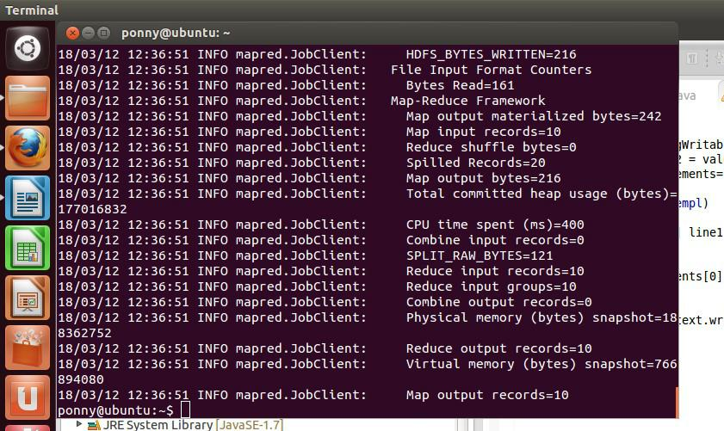

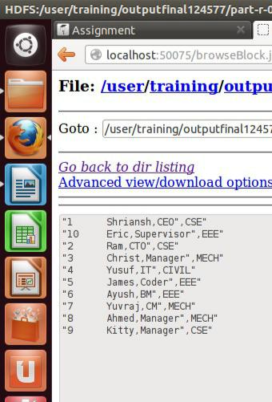

Question-2

Create the customer details(cid,name) and the transaction details(cid, transaction amount) file in hdfs. Write the cname, number of transactions and transaction amount in hdfs. Use reduce side join.

CODE

import java.io.BufferedReader;

import java.io.FileReader;

import java.io.IOException;

import java.nio.file.FileSystem;

import java.util.*;

import org.apache.hadoop.filecache.DistributedCache; import org.apache.hadoop.fs.Path;

import org.apache.hadoop.conf.*;

import org.apache.hadoop.io.*;

import org.apache.hadoop.mapreduce.*;

import org.apache.hadoop.mapreduce.Reducer.Context; import org.apache.hadoop.mapreduce.lib.output.*; import org.apache.hadoop.mapreduce.lib.input.*;

public class reducejoin {

public static class empmapper extends Mapper<LongWritable,Text,Text,Text> { public void map(LongWritable key, Text value, Context context) throws

IOException, InterruptedException {

String line2 = value.toString();

String[] line=line2.split(",");

context.write(new Text(line[0]), new Text("cust"+","+line[1]));

}

}

public static class depmapper extends Mapper<LongWritable,Text,Text,Text>

{

public void map(LongWritable key, Text value, Context context) throws IOException, InterruptedException {

String line2 = value.toString();

String[] line=line2.split(",");

context.write(new Text(line[0]), new Text("trans"+","+line[1]));

}

}

public static class jreducer extends Reducer<Text,Text,Text,Text>

{

String st1;

public void reduce(Text key, Iterable<Text> values, Context context ) throws IOException, InterruptedException {

int c=0,amt=0;

for(Text val:values)
{

String[] line = val.toString().split(",");

if (line[0].equals("trans"))

{

c=c+1;

amt+= Integer.parseInt(line[1]);

}

else if (line[0].equals("cust"))

{

st1 = line[1];

}

}

context.write(new Text(st1), new Text(c+","+amt));

}

}

public static void main(String[] args) throws Exception{ Configuration conf = new Configuration();

Job job = new Job(conf, "reducejoin");

job.setJarByClass(reducejoin.class);

job.setJobName("Compare Two Files and Identify the Difference");

//Path outputPath = new Path(args[2]);

//FileSystem hdfs = FileSystem.get(conf); //hdfs.delete(outputPath, true); job.setReducerClass(jreducer.class); job.setOutputKeyClass(Text.class); job.setOutputValueClass(Text.class); MultipleInputs.addInputPath(job, new Path(args[0]), TextInputFormat.class, empmapper. class); MultipleInputs.addInputPath(job, new Path(args[1]), TextInputFormat.class, depmapper.class); FileOutputFormat.setOutputPath(job, new Path(args[2])); job.waitForCompletion(true);

}

}

OUTPUT
